**K-means Clustering Algorithm: Know How It Works**

We do understand that not all customers are alike and have the same taste. So, this leads to the challenge of marketing the right product to the right customer. An offer or product which might entice a particular customer segment may not be very helpful to other segments. So, you can apply k-means clustering algorithm to segment your entire customer audience into groups with similar traits and preferences based on various metrics (such as their activities, likes and dislikes on social media and their purchase history). Based on these customer segments identified, you can create personalized marketing strategies and bring more business to your organisation.

I hope you enjoyed reading my previous blog – [What is Data Science](https://www.edureka.co/blog/what-is-data-science/) which covers Machine Learning and the lifecycle of Data Science in detail. Before delving into k-means clustering directly, I will be covering following topics to give you a basic understanding of clustering.

* Introduction to Machine Learning
* The need of clustering with examples
* What is clustering?
* Types of clustering
* k-means clustering
* Hands-on: Implementation of k-means clustering on movie dataset using R. Cluster formation of movies based on their business and popularity among viewers.

Machine Learning is one of the most recent and exciting technologies. You probably use it dozen of times a day without even knowing it. Machine Learning is a type of artificial intelligence that provides computers with an ability to learn without being explicitly programmed. It works on supervised and unsupervised learning models. Unlike supervised learning model, the unsupervised model of Machine Learning has no predefined groups under which you can distribute your data. You can find these groupings through clustering. I will explain it further through the following examples.

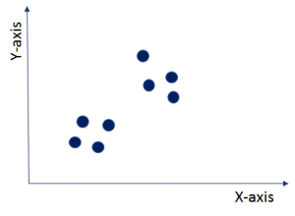

As you can see in this image, the data points are shown as blue dots. These data points do not have labels based on which you can differentiate them. You do not know anything about this data. So now the question is, can you find out any structure in this data? This problem can be solved using clustering technique. Clustering will divide this entire dataset under different labels (here called clusters) with similar data points into one cluster as shown in the graph given below. It is used as a very powerful technique for exploratory descriptive analysis.

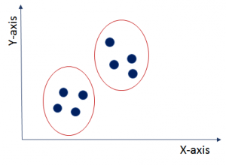Here, the clustering technique has partitioned the entire data points into two clusters. The data points within a cluster are similar to each other but different from other clusters. For example, you have the data on symptoms of patients. Now, you can find out the name of a particular disease based on these symptoms.

Let’s understand clustering further with an example of google news.

What google news does is that every day with hundreds and thousands of news coming up on the web, it groups them into cohesive news stories. Let’s see how?

Once you go to news.google.com, you will see numerous news stories grouped as shown below.

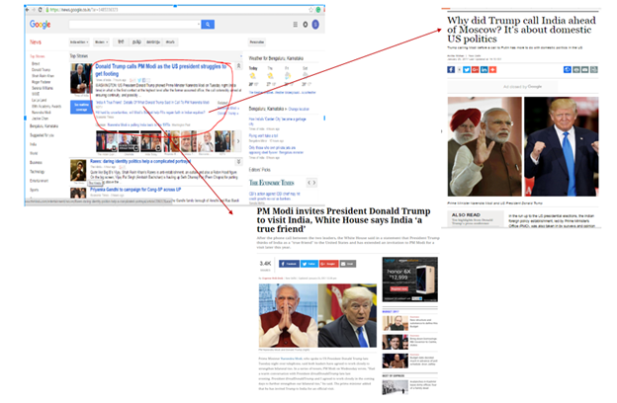

They are grouped into different news stories. Here, if you see the red highlighted area, you will get to know that various news URLs related to Trump and Modi are grouped under one section and rest in other sections. On clicking different URL from the group, you will get a different story on the same topic. So, google news automatically clusters new stories about the same topic into pre-defined clusters.

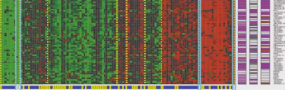

Another very fascinating application of clustering is in *genomics*. Genomics is the study of DNA. As you can see in the image, different colors like red, green and grey depict the degree to which individual does or does not has a specific gene. So, you can run clustering algorithm on the DNA data of a group of people to create different clusters. This can give you very valuable insights into the health of particular genes.

For example, people with Duffy-negative genotype tend to have higher resistance to malaria and are generally found in African regions. So, you can draw a relationship between the genotype, the native habitat and find out their response to particular diseases.

So, basically clustering partitions the dataset with similarities into different groups which can act as a base for further analysis. The result will be that objects in one group will be similar to one another but different from objects in another group.

**K-means Clustering Algorithm: Know How It Works**

*Recommended by 121 users*





[**Hemant Sharma**](https://www.edureka.co/blog/author/hemantedureka-co/)

Published on Dec 07,2018

   [3 Comments](https://www.edureka.co/blog/k-means-clustering-algorithm/#disqus_thread)

 11.6K Views

[Bookmark](https://www.edureka.co/blog/k-means-clustering-algorithm/)

Email Post

We do understand that not all customers are alike and have the same taste. So, this leads to the challenge of marketing the right product to the right customer. An offer or product which might entice a particular customer segment may not be very helpful to other segments. So, you can apply k-means clustering algorithm to segment your entire customer audience into groups with similar traits and preferences based on various metrics (such as their activities, likes and dislikes on social media and their purchase history). Based on these customer segments identified, you can create personalized marketing strategies and bring more business to your organisation.

I hope you enjoyed reading my previous blog – [What is Data Science](https://www.edureka.co/blog/what-is-data-science/) which covers Machine Learning and the lifecycle of Data Science in detail. Before delving into k-means clustering directly, I will be covering following topics to give you a basic understanding of clustering.

* Introduction to Machine Learning
* The need of clustering with examples
* What is clustering?
* Types of clustering
* k-means clustering
* Hands-on: Implementation of k-means clustering on movie dataset using R. Cluster formation of movies based on their business and popularity among viewers.

Machine Learning is one of the most recent and exciting technologies. You probably use it dozen of times a day without even knowing it. Machine Learning is a type of artificial intelligence that provides computers with an ability to learn without being explicitly programmed. It works on supervised and unsupervised learning models. Unlike supervised learning model, the unsupervised model of Machine Learning has no predefined groups under which you can distribute your data. You can find these groupings through clustering. I will explain it further through the following examples.



As you can see in this image, the data points are shown as blue dots. These data points do not have labels based on which you can differentiate them. You do not know anything about this data. So now the question is, can you find out any structure in this data? This problem can be solved using clustering technique. Clustering will divide this entire dataset under different labels (here called clusters) with similar data points into one cluster as shown in the graph given below. It is used as a very powerful technique for exploratory descriptive analysis.

Here, the clustering technique has partitioned the entire data points into two clusters. The data points within a cluster are similar to each other but different from other clusters. For example, you have the data on symptoms of patients. Now, you can find out the name of a particular disease based on these symptoms.

Let’s understand clustering further with an example of google news.

What google news does is that every day with hundreds and thousands of news coming up on the web, it groups them into cohesive news stories. Let’s see how?

Once you go to news.google.com, you will see numerous news stories grouped as shown below.



They are grouped into different news stories. Here, if you see the red highlighted area, you will get to know that various news URLs related to Trump and Modi are grouped under one section and rest in other sections. On clicking different URL from the group, you will get a different story on the same topic. So, google news automatically clusters new stories about the same topic into pre-defined clusters.

Another very fascinating application of clustering is in *genomics*. Genomics is the study of DNA. As you can see in the image, different colors like red, green and grey depict the degree to which individual does or does not has a specific gene. So, you can run clustering algorithm on the DNA data of a group of people to create different clusters. This can give you very valuable insights into the health of particular genes.

For example, people with Duffy-negative genotype tend to have higher resistance to malaria and are generally found in African regions. So, you can draw a relationship between the genotype, the native habitat and find out their response to particular diseases.

So, basically clustering partitions the dataset with similarities into different groups which can act as a base for further analysis. The result will be that objects in one group will be similar to one another but different from objects in another group.

[**Data Science Certification Course using R**Watch The Course Preview](https://www.edureka.co/data-science)

Now, once you have understood what is clustering, let’s look at different ways to achieve these clusters.

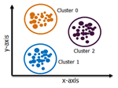

**Exclusive Clustering**:

In exclusive clustering, an item belongs exclusively to one cluster, not several. In the image, you can see that data belonging to cluster 0 does not belong to cluster 1 or cluster 2. k-means clustering is a type of exclusive clustering.

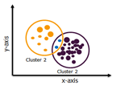

**Overlapping Clustering**:

Here, an item can belong to multiple clusters with different degree of association among each cluster. Fuzzy C-means algorithm is based on overlapping clustering.

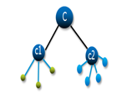

**Hierarchical Clustering**: In hierarchical clustering, the clusters are not formed in a single step rather it follows series of partitions to come up with final clusters. It looks like a tree as visible in the image.

While implementing any algorithm, computational speed and efficiency becomes a very important parameter for end results. So, I have explained k-means clustering as it works really well with large datasets due to its more computational speed and its ease of use.

**k-means Clustering**

k-means clustering is one of the simplest algorithms which uses unsupervised learning method to solve known clustering issues. k-means clustering require following two inputs.

1. k = number of clusters
2. Training set(m) = {x1, x2, x3,……….., xm}

Let’s say you have an unlabeled data set like the one shown below and you want to group this data into clusters.

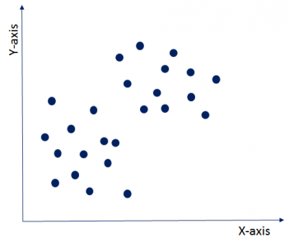

Now, the important question is how should you choose the optimum number of clusters? There are two possible ways for choosing the number of clusters.

**(i)   Elbow Method:**Here, you draw a curve between WSS (within sum of squares) and the number of clusters. It is called elbow method because the curve looks like a human arm and the elbow point gives us the optimum number of clusters. As you can see that after the elbow point, there is a very slow change in the value of WSS, so you should take the elbow point value as the final number of clusters.

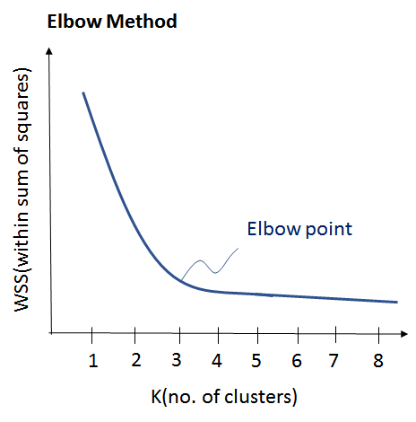

**(ii)**  **Purpose Based:**You can run k-means clustering algorithm to get different clusters based on a variety of purposes. You can partition the data on different metrics and see how well it performs for that particular case. Let’s take an example of marketing T-shirts of different sizes. You can partition the dataset into different number of clusters depending upon the purpose that you want to meet. In the following example, I have taken two different criteria, price and comfort.

Let’s see these two possibilities as shown in the image below.

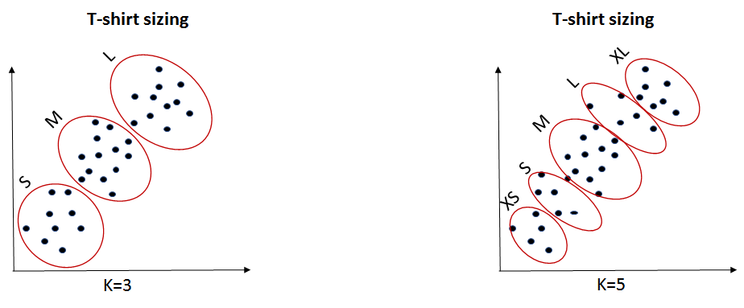

1. K=3:  If you want to provide only 3 sizes(S, M, L) so that prices are cheaper, you will divide the data set into 3 clusters.
2. K=5: Now, if you want to provide more comfort and variety to your customers with more sizes (XS, S, M, L, XL), then you will divide the data set into 5 clusters.

Now, once we have the value of k with us, let’s understand it’s execution.

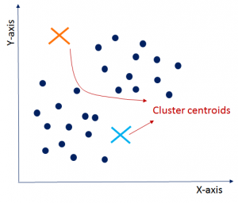

* **Initialisation:**  
  Firstly, you need to randomly initialise two points called the cluster centroids. Here, you need to make sure that your cluster centroids depicted by an orange and blue cross as shown in the image are less than the training data points depicted by navy blue dots. k-means clustering algorithm is an iterative algorithm and it follows next two steps iteratively. Once you are done with the initialization, let’s move on to the next step.

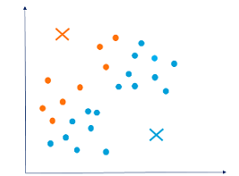

* **ClusterAssignment:**In this step, it will go through all the navy-blue data points to compute the distance between the data points and the cluster centroid initialized in the previous step. Now, depending upon the minimum distance from the orange cluster centroid or blue cluster centroid, it will group itself into that particular group. So, data points are divided into two groups, one represented by orange color and the other one in blue color as shown in the graph. Since these cluster formations are not the optimized clusters, so let’s move ahead and see how to get final clusters.

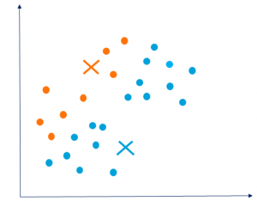

* **Move Centroid:**  
  Now, you will take the above two cluster centroids and iteratively reposition them for optimization. You will take all blue dots, compute their average and move current cluster centroid to this new location. Similarly, you will move orange cluster centroid to the average of orange data points. Therefore, the new cluster centroids will look as shown in the graph. Moving forward, let’s see how can we optimize clusters which will give us better insight.  
    
  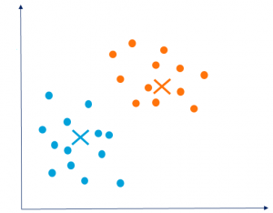
* **Optimization:**  
  You need to repeat above two steps iteratively till the cluster centroids stop changing their positions and become static. Once the clusters become static, then k-means clustering algorithm is said to be converged.
* **Convergence:**Finally, k-means clustering algorithm converges and divides the data points into two clusters clearly visible in orange and blue. It can happen that k-means may end up converging with different solutions depending on how the clusters were initialised.